**HANDS_ON_9(“cricketapp”)**

**1. src/components/ListofPlayers.js**

import React from 'react';

export default function ListofPlayers({ players }) {

return (

<div>

{players.map((item, index) => (

<div key={index}>

<li>

Mr. {item.name} <span>{item.score}</span>

</li>

</div>

))}

</div>

);

}

**2. src/components/Scorebelow70.js**

import React from 'react';

export default function Scorebelow70({ players }) {

const players70 = [];

players.map((item) => {

if (item.score <= 70) {

players70.push(item);

}

});

return (

<div>

{players70.map((item, index) => (

<li key={index}>

Mr. {item.name} <span>{item.score}</span>

</li>

))}

</div>

);

}

**3. src/components/OddPlayers.js**

import React from 'react';

export default function OddPlayers({ players }) {

const [first,, third,, fifth] = players;

return (

<div>

<li>First: {first}</li>

<li>Third: {third}</li>

<li>Fifth: {fifth}</li>

</div>

);

}

**4. src/components/EvenPlayers.js**

import React from 'react';

export default function EvenPlayers({ players }) {

const [, second,, fourth,, sixth] = players;

return (

<div>

<li>Second: {second}</li>

<li>Fourth: {fourth}</li>

<li>Sixth: {sixth}</li>

</div>

);

}

**5. src/components/ListofIndianPlayers.js**

import React from 'react';

export default function ListofIndianPlayers({ IndianPlayers }) {

return (

<div>

{IndianPlayers.map((player, index) => (

<li key={index}>Mr. {player}</li>

))}

</div>

);

}

**6. src/data/IndianPlayers.js**

const T20Players = ['First Player', 'Second Player', 'Third Player'];

const RanjiTrophyPlayers = ['Fourth Player', 'Fifth Player', 'Sixth Player'];

export const IndianPlayers = [...T20Players, ...RanjiTrophyPlayers];

**7. src/App.js**

import React from 'react';

import ListofPlayers from './components/ListofPlayers';

import Scorebelow70 from './components/Scorebelow70';

import OddPlayers from './components/OddPlayers';

import EvenPlayers from './components/EvenPlayers';

import ListofIndianPlayers from './components/ListofIndianPlayers';

import { IndianPlayers } from './data/IndianPlayers';

function App() {

var flag = false;

var flag= true;

const players = [

{ name: 'Jack', score: 50 },

{ name: 'Michael', score: 70 },

{ name: 'John', score: 40 },

{ name: 'Ann', score: 61 },

{ name: 'Elisabeth', score: 61 },

{ name: 'Sachin', score: 95 },

{ name: 'Dhoni', score: 100 },

{ name: 'Virat', score: 84 },

{ name: 'Jadeja', score: 64 },

{ name: 'Raina', score: 75 },

{ name: 'Rohit', score: 80 }

];

const IndianTeam = [

'Sachin1',

'Dhoni2',

'Virat3',

'Rohit4',

'Yuvaraj5',

'Raina6'

];

if (flag === true) {

return (

<div>

<h1>List of Players</h1>

<ListofPlayers players={players} />

<hr />

<h1>List of Players having Scores Less than 70</h1>

<Scorebelow70 players={players} />

</div>

);

} else {

return (

<div>

<div>

<h1>Indian Team</h1>

<h2>Odd Players</h2>

<OddPlayers players={IndianTeam} />

<hr />

<h2>Even Players</h2>

<EvenPlayers players={IndianTeam} />

</div>

<hr />

<div>

<h2>List of Indian Players Merged:</h2>

<ListofIndianPlayers IndianPlayers={IndianPlayers} />

</div>

</div>

);

}

}

export default App;

**8. src/index.js**

import React from 'react';

import ReactDOM from 'react-dom/client';

import App from './App';

const root = ReactDOM.createRoot(document.getElementById('root'));

root.render(<App />);

**OUTPUT BROWSER:**

**When flag = true;**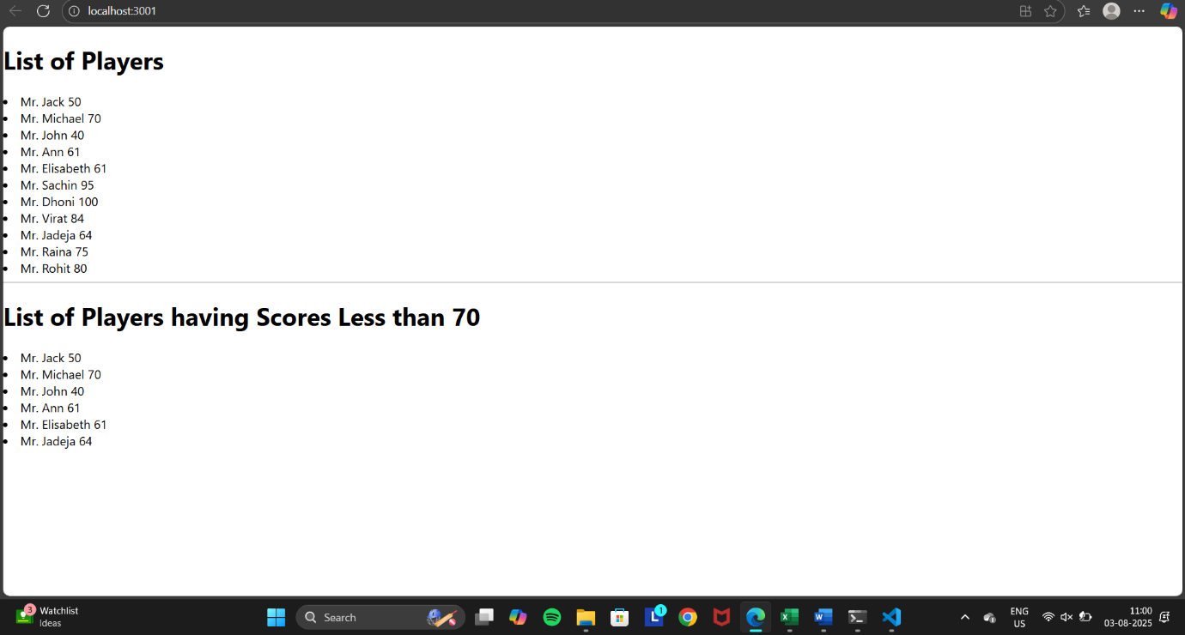

**When flag= false;**

